Student Survey: Soil pH

- Which of the following is a beaker?
  - 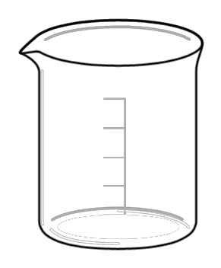 b. c. d. 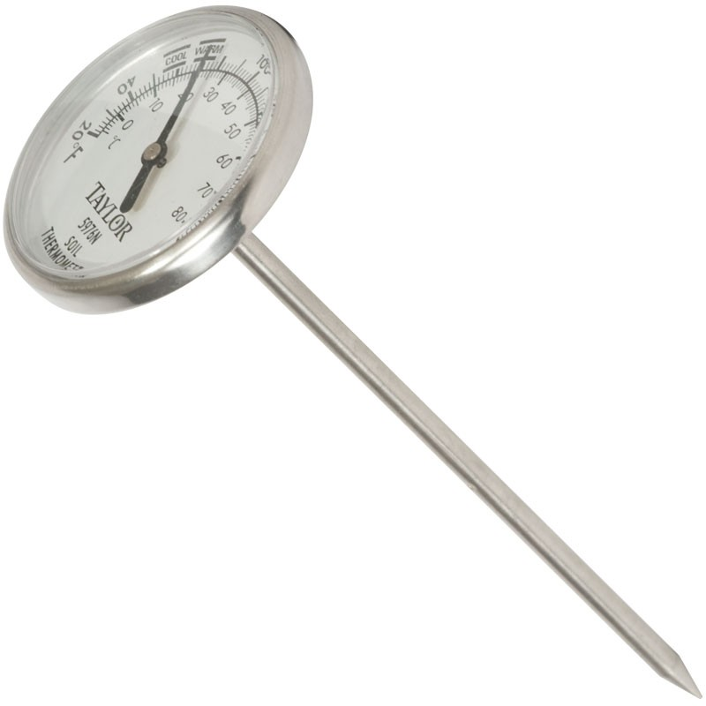

- To take the pH of soil, you must:
  - Let it settle in a beaker of water
  - Take the pH of the water in the beaker
  - Take the pH of pond water
  - Both a and b

- The pH of soil tells us
  - How acidic it is
  - How tightly packed it is
  - How wet it is
  - What temperature it is

Soil pH

- Which of the following is a beaker?
  - b. c. d.

- To take the pH of soil, you must:
  - Let it settle in a beaker of water
  - Take the pH of the water in the beaker
  - Take the pH of pond water
  - Both a and b

- The pH of soil tells us
  - How acidic it is
  - How tightly packed it is
  - How wet it is
  - What temperature it is

