Student Survey: Soil Characterization

- What tool is used to define the color of soil?
- trowel
- tape measure
- Munsell Soil Color Chart
- Abridged Soil Color Table

- What is a soil horizon?
- the area where the landscape meets the sky
- a layer of soil with unique characteristics
- the soil around the edge of a ditch
- an area of soil that holds up a building

- If you can’t break a small bead of soil with your fingers, its consistence is:
- extremely firm
- loose
- friable
- yellow-red

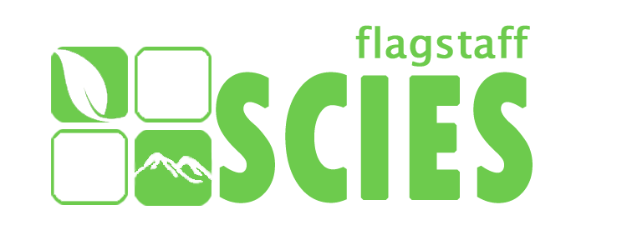

Student Survey: Soil Characterization

- What tool is used to define the color of soil?
- trowel
- tape measure
- Munsell Soil Color Chart
- Abridged Soil Color Table

- What is a soil horizon?
- the area where the landscape meets the sky
- a layer of soil with unique characteristics
- the soil around the edge of a ditch
- an area of soil that holds up a building

- If you can’t break a small bead of soil with your fingers, its consistence is:
- extremely firm
- loose
- friable
- yellow-red

